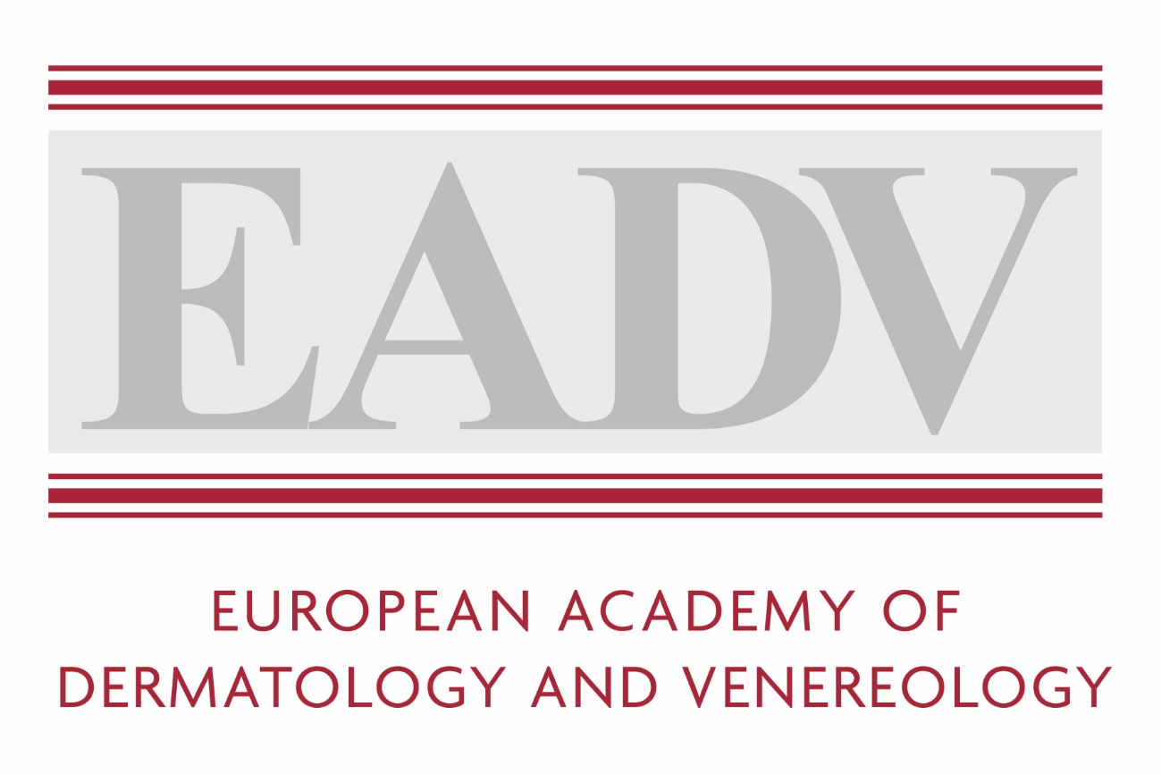

Media and Embargo Policy
29th Congress EADV Virtual
New Frontiers in Dermatology and Venereology
29th - 31st October 2020

Contents
1 General Media Regulations 2
2 Accreditation, Registration and Access 2
3 Embargo Policy 3
4 Filming, Photography, Recording Rules 4
5 Termination and/or revocation of Media Credentials 5
6 Acceptance of Media 6

General Media Regulations
Any media outlet or press representative (journalists, reporters, photographers, etc.) wishing to attend the EADV events (Symposium and Congress) and/or other events of EADV must adhere to the EADV media and embargo policy. Signing of the EADV Media and Embargo Policy is a prerequisite for Press registration (online)
Anyone who violates the EADV media and embargo policy will be penalised. The penalty may be immediate revocation of press credentials, exclusion from the EADV event and a denial of access to all EADV events for two years or more. See section 5.
EADV and/or affiliated trademarks, banners and logos are the property of EADV. They cannot be used, reproduced or associated with any article or press release without the prior written permission of EADV. To get the permission please send your request and the relevant material to the EADV Press Office: EADVmedia@saycomms.co.uk.
EADV does not make its press database or registration lists available to third parties. It reserves the right to disclose after the event the list of press agencies, without any data subject to GDPR regulations.

Accreditation, Registration and Access
Press accreditation and registration is required to attend any EADV event. Press registration is complimentary and includes the following services (offered at the EADV congress):
- Access to all EADV scientific sessions, exhibition halls, press conferences, press material and interviews arranged with EADV spokespersons etc.
- Industries are allowed to restrict access of press to their Industry Satellite Sessions or HUBs
Media outlets and press representatives are asked to pre-register. To get a free press pass they are requested to send the following to the EADV Press Office at EADVmedia@saycomms.co.uk. A valid press card or an appropriate letter of assignment with two recent published articles with your by-line on the article (dermatology or venereology-related, or referring to a previous EADV event). Company, media outlet business cards are not accepted as credentials.
- The completed press registration form
Press registration is open to any media outlet and/or its press representative:
- Journalists/reporters/correspondents/Editors
- Freelance journalists (must declare who they represent)
- Media specific photographers/videographers
- Online media
- News agencies and newswire services
- Broadcast media (TV, radio)
- Medical journals
- Newsletters
- Blogs/medical blogs that are widely accessible and consistently publish editorial news coverage, that is not controlled by sponsors/advertisers
Please note that access to the EADV Virtual Congress is for members of the medical and professional media only. Members of the consumer media who require access will be considered on a case by case basis.
Press registration is not available to industry or its public relations representatives, event management, media outlet managers, marketing, sales or communications representatives, even if they have a valid press card. Please check the registration page (https://eadvvirtualcongress.org/registration/) to find alternative registration options.
The EADV has the right to withhold approval of press registration if the applicant and/or the outlet do not satisfy the criteria for press registration or if the media registration form is sent without the required supporting documents/completed registration form.
The decision of the EADV is final regarding all press registration requests.

Embargo Policy
Any media outlet or press representative wishing to attend an EADV event and/or to obtain official press releases from EADV, must commit to respecting any and all embargoes set by EADV. Press representatives who receive embargoed material from EADV understand that it is for their individual use and will not distribute the embargoed information to anyone else prior to the embargo release. Embargoed materials include – but are not limited to – original journal articles, abstracts from scientific meetings, written news releases, audio news releases, video news releases, interviews, slides and any other materials associated with the scientific information being presented or published.
Embargoed materials as well as results and information related to sessions at any meeting or event organised by EADV, are strictly confidential and cannot be disclosed in any manner or for any purpose prior to the lifting of the embargo by EADV.
For all sort of presentations at EADV events, the embargo is lifted with the start of the scientific session in which the concerned presentation/study is scheduled. For any questions related to embargoes, please contact the EADV Press Office at SAY Communications for clarification prior to releasing the information via EADVmedia@saycomms.co.uk. Abstracts are included in this embargo policy.
Please note that embargoed materials may be protected by copyright and cannot be reproduced without prior permission from the author.
Media outlets and press representatives, are expected to abide by the full EADV media and embargo policy and ensure that any member of staff or any third party acting on their behalf and/or under their authority, comply with the EADV media and embargo policy.
Breaking of an EADV embargo by any media outlet, press representative, member of staff or any third party acting on behalf of and/or under the authority of any media outlet or press representative is a contractual breach. The person/entity who released the information (i.e. the press representative who wrote the story/conducted the interview etc.) will be held accountable and will be subjected to the penalties listed below in Section 5.
Should circumstances arise in which publicly traded companies ask to disclose their submitted data prior to the EADV event for legal reasons or in order to comply with Securities and Exchange Commission requirements, the EADV may grant exceptional permission to release specific data. The EADV reserves all rights to determine what information can be released and to decline any request. The disclosure of any additional information, analysis or commentary is strictly forbidden and will be considered a breach of the Embargo Policy. These special circumstances must be requested via email to the Head of Corporate Relations Kimberley.zimmermann@eadv.org.

Filming, Photography, Recording Rules
- All digital recordings, video or audio recordings, online recording tools and screenshots are strictly prohibited during a scientific presentation or session without permission.
- Photos/recordings taken during an ESC event are subject to protection of intellectual property, image and privacy rights. No screenshots or recordings are allowed.
- Any video transmission or webcast from an EADV event must adhere to the EADV Media and Embargo Policy and only be published/available online after the start of the scientific session it refers to.
- Presenters are the sole proprietors of the content they disclose at EADV events (data, photographs, slides, etc.) It is the responsibility of presenters or speakers to notify the audience of any restrictions on photographing or video/audio recording the content they are presenting. The announcement must be made at the beginning of each presentation. Throughout EADV events, no scientific session presenter or exhibitor may be filmed, recorded (audio or visual), screenshots taken or photographed without his/her consent (including the use of smart phones, mobile devices, tablets, laptops, dictaphones, online recoding tools etc.).
- Media outlets or press representatives who wish to film, take photos, screenshots and/or record (audio or visual) during all scientific sessions must have permission to do so arranged directly with the speaker. For assistance in your enquiry you can also contact the EADV Press Office via EADVmedia@saycomms.co.uk with the specific session and request.
- Commercial use of images taken at any EADV events is strictly forbidden.
- Any public dissemination of photos, recordings or videos taken at an EADV event must include the name of the specific event as a credit.
- The official EADV trademark and/or logo may not be added without EADV prior written approval.
- Any video transmission or webcast from an EADV virtual event must adhere to the Embargo Policy.
- The EADV will provide a filming/photo pass, for a specific time / scientific session. Please contact the EADV Press Office via EADVmedia@saycomms.co.uk to get the permission. Please note that all slides are copyrighted material and cannot be reproduced without prior permission from the author.
- The EADV will approve requests on a case-by-case basis. Only registered media outlets or press representatives will be allowed to film, take photos and/or record at any EADV events.
- Commercial use of images, videos, recordings taken at EADV events is strictly forbidden.
- Industry representatives or public relations/communication agencies organising Industry Press Conferences, Industry-sponsored sessions and/or meetings at EADV events are responsible for protecting their content and enforcing their rules.
Media outlets and press representatives, are expected to abide by the full EADV media and embargo policy, including the filming/photography/recording (audio or visual) policy and logo policy for EADV events, and to make sure that any member of staff or any third party acting on their behalf and/or under their authority, comply with the said EADV media and embargo policy.
Breaking of the Photo / Video / Audio Recording Rules by any media outlet, press representative, member of staff or any third party acting on behalf of and/or under the authority of any media outlet or press representative is a contractual breach that may lead to sanctions under the conditions set forth in section 5.

Termination and/or revocation of Media Credentials
It is agreed that press representatives are responsible for their actions during EADV events and for those of any third party acting on their behalf and/or under their authority, whether on site or offsite, and for any publication or other communication containing results and information related to an EADV event (including virtual). Media outlets are also responsible for the action of the press representative, staff and any third party acting on their behalf and/or under their authority and for any publication containing results and information related to any EADV Event.
Consequently, in the event of a breach of any provision of the present EADV media and embargo policy by any media outlet, press representative, member of staff or any third party acting on behalf of and/or under the authority of any media outlet or press representative, EADV reserves the right to terminate immediately, without notice and without prejudice to any claim for damages or other remedy by any third party, the agreement given to any registered participant and their representatives to attend an EADV event (including virtual).
Breaking of any provision of the EADV Media and Embargo Policy by any media outlet, press representative, member of staff or any third party acting on behalf of and/or under the authority of any media outlet or press representative is a contractual breach that may also lead to:
- Immediate suspension of the press representative’s media credentials
- Immediate barring of the press representative from the virtual event
- Removal of the press representative’s name and/or of its media outlet from the EADV Press distribution list for two years or more starting from the time of the EADV Media and Embargo Policy break
- No access for the press representative to any EADV event (virtual or otherwise) for two years or more starting from the time of the EADV Media and Embargo Policy break
- No access for any press representative from the offending media to any EADV Event (including virtual) for two years or more starting from the time of the EADV Media and Embargo Policy break
- The EADV may communicate the EADV Media and Embargo Policy break and sanctions to its media lists
- And any other measure deemed appropriate to preserve EADV rights (or member rights), without prejudice to any claim for damages or other remedy by any third party
The absence of termination of the agreement and/or of any sanction from EADV does not constitute an acknowledgment of the media outlet or press representative misconduct and EADV reserves the right to proceed to the said termination and/or sanction at any time.
All matters arising from or connected with the compliance to the EADV media and embargo policy will be governed by Swiss Law, without reference to the conflict of laws principles. Any dispute arising out of this commitment shall be brought before the court in Switzerland.

Acceptance of Media
I have read and been informed about the EADV Media and Embargo policy and agree to abide by the policy guidelines as a condition to attend the EADV events (including virtual) as media outlet or press representative (journalists, reporters, bloggers, photographers, videographers etc.). Signing of the EADV Media and Embargo Policy is a prerequisite for Press registration (online)

Title: |  |  | Gender:
Email address:
First Name:
Family Name:
Nationality:

Name of the media organization/publication:
Title and Name of the Contact person (supervisor):
Work Address:
Zip Code: |  |  | City:
Country:
Phone Number: |  |  | Mobile:

Date: Signature and Stamp:

